
Using Advanced Features of GeoGebra 4 to
Design Learning and Teaching Tasks in Mathematics
GeoGebra Institute of Hong Kong
Aug 2013
Useful Commands
The full list is available at http://wiki.geogebra.org/en/Commands.
Algebra  Expand, Factor  Simplify  GCD, LCM  Div, Mod, Division  Divisors, DivisorsList  PrimeFactors  NextPrime, PreviousPrime  Min, Max  FromBase, ToBase  MixedNumber, Rationalize  Chart  BarChart  BoxPlot  DotPlot  FrequencyPolygon  Histogram  StemPlot  Function  CompleteSquare  Coefficients  Degree  Factors  Function  Polynomial  ImplictCurve  Root, Roots, ComplexRoot  Limit  Derivatives  Extremum  Integral, IntegralBetween  UpperSum, LowerSum  LeftSum, RightSum  RectangleSum  TrapezoidalSum | GeoGebra  AxisStepX, AxisStepY  Corner  DynamicCoordinates  Name, Object  SlowPlot  List  Append, Insert, Join  Element, Take  First, Last  Intersection, Union  RandomElement  RemoveUndefined  Reverse, Sort  SelectedElement  SelectedIndex  Unique, Frequency  Sequence  Logical  CountIf  If  IsDefined  IsInRegion  IsInteger  IsPrime  KeepIf  Probability  BinomialCoefficient  nPr  RandomBetween | Scripting  SetAxesRatio  SetCaption, SetColor  SetFixed  SetValue  SetVisibleInView  SetTrace  ShowAxes  ShowGrid  UpdateConstruction  ZoomIn, ZoomOut  Statistics  FrequencyTable  Mean, Median, Mode  Q1, Q3  SD, Variance  Shuffle  Text  FormulaText  FractionText  TableText  Ordinal  Vector and Matrix  Dimension  Determinant  Invert, Transpose  ReducedRowEchelonForm  PerpendicularVector  UnitPerpendicularVector  Vector, UnitVector

Task 1 Trace and Locus

- Input: Polygon[(0, 0), (3, 0), (3, 2), (0, 2)] and fix this rectangle. Set it black, transparent and its line thickness to “6”.
- Input: Point[poly1] to create a point A moving on the rectangle.
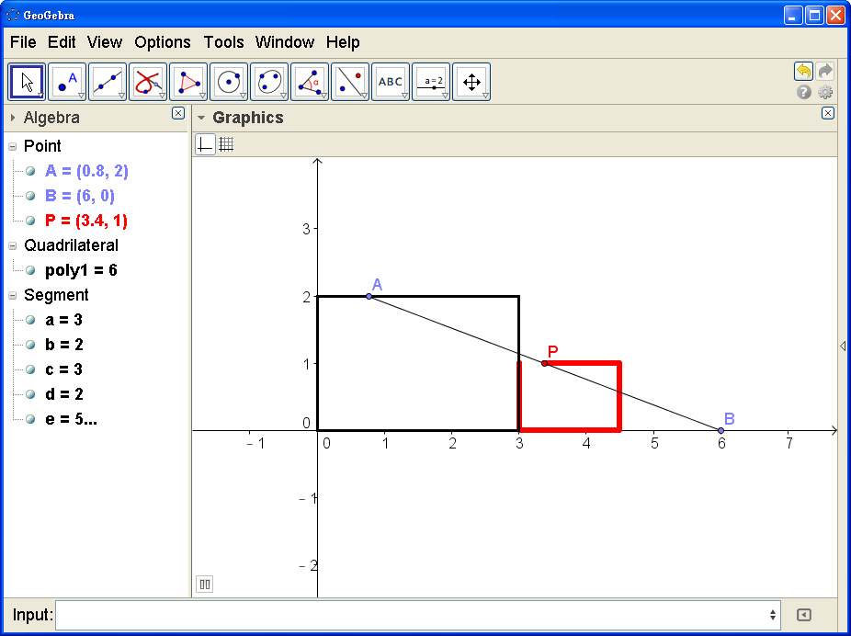
- Create a fixed point B(6, 0).
- Draw the line segment. Create its mid-point P. Colour P in red.
- Rick-click P and choose “Trace On”.
- Rick-click A and choose “Animation On” to move A. Click the button at the lower-left corner of the Graphics view to stop the animation.
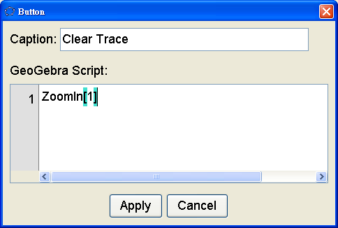
- Use the “Button”  tool in the Action Object toolbox 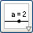. Click on a position.
Type “Clear Trace” in the “Caption” field.
Enter: ZoomIn[1] in the “GeoGebra Script” window and choose “Apply”.
- Right-click P and unselect “Trace On”. Click the “Clear Trace” button to clear the trace of P.
- Use the “Locus” tool 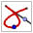 in the Special Lines toolbox 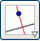. Click on P and then A to create the locus of P when A moves on the circle. Colour this locus in red.
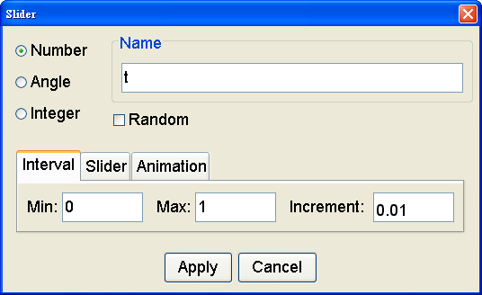
- To the “Slider” tool to create a slider for a variable t which takes the value from 0 to 1 with increment 0.01.
- Input: P = t A + (1-t)B to redefine P as a movable point on the segment AB.
- Drag the slider of t to move P along the line segment. Observe the locus of P.
- Right-click the locus of P and choose “Trace On”. Drag t to show the trace of the locus.
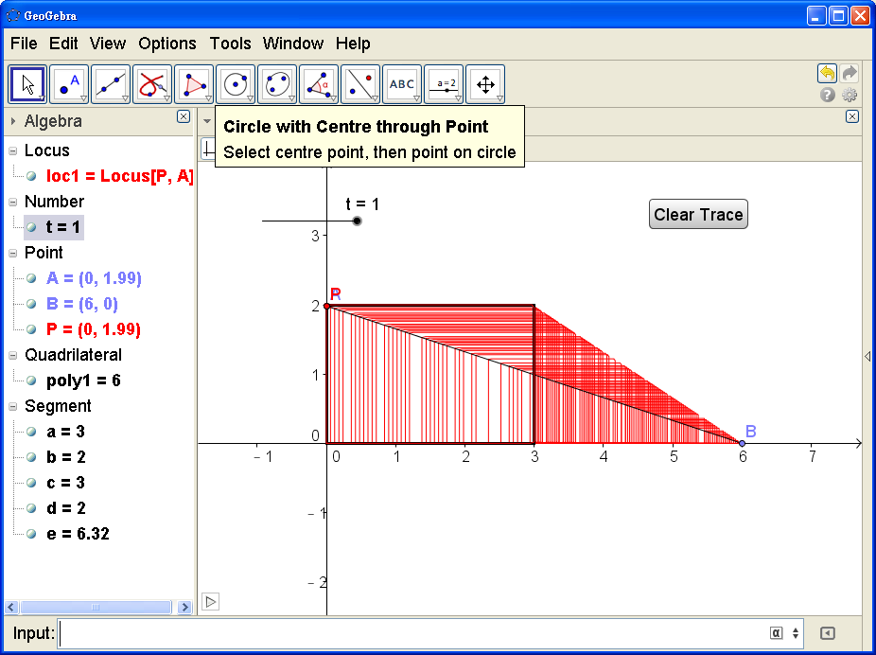
Task 2 Coloring a Region Enclosed by Arcs

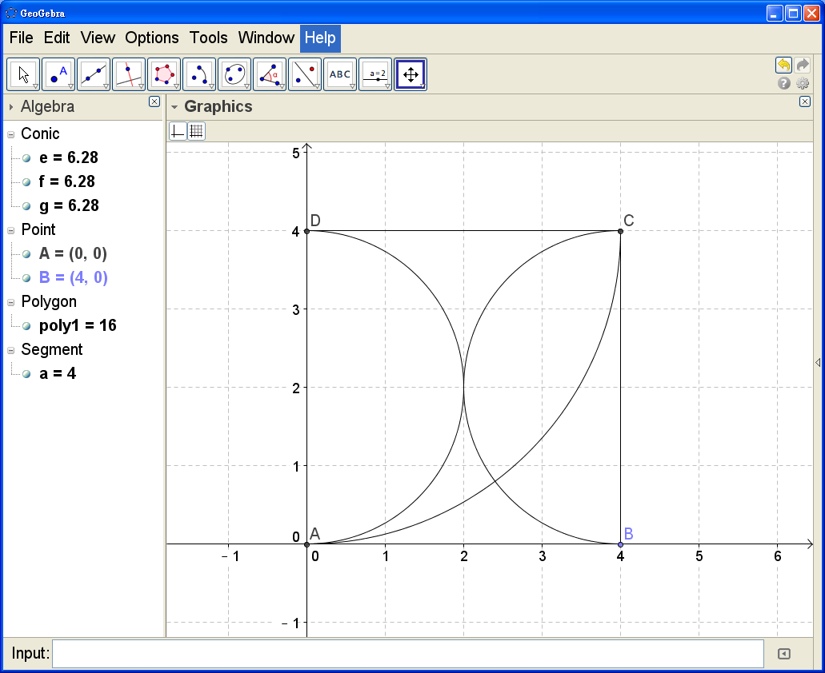
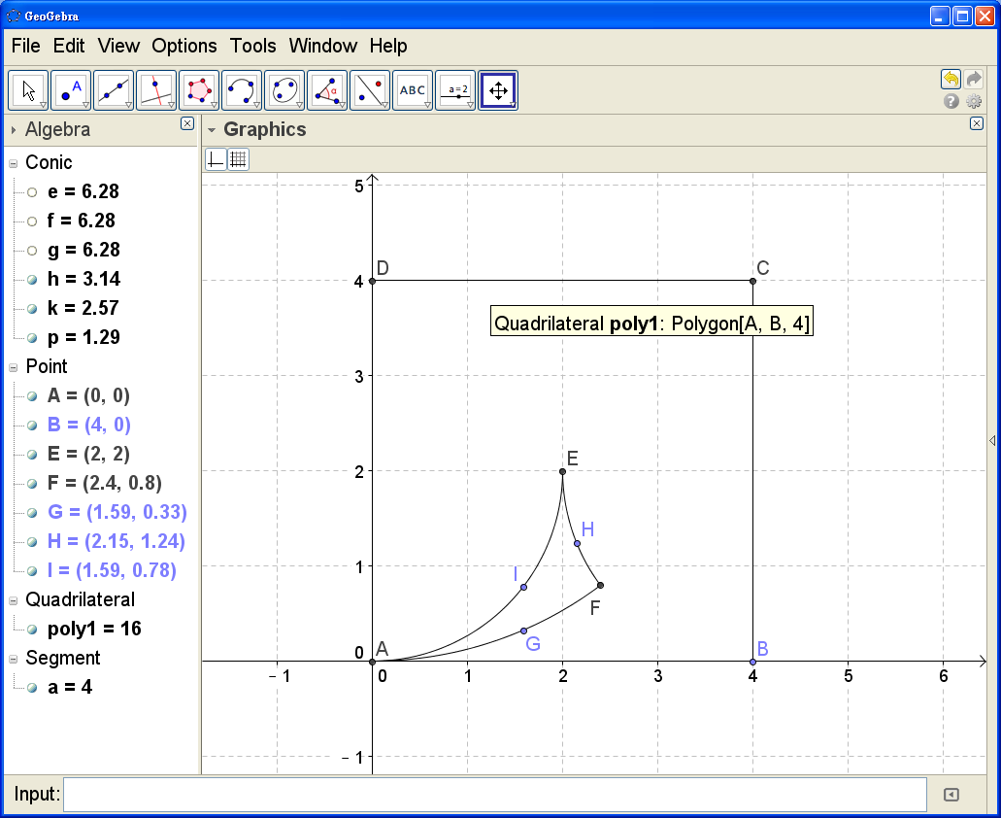
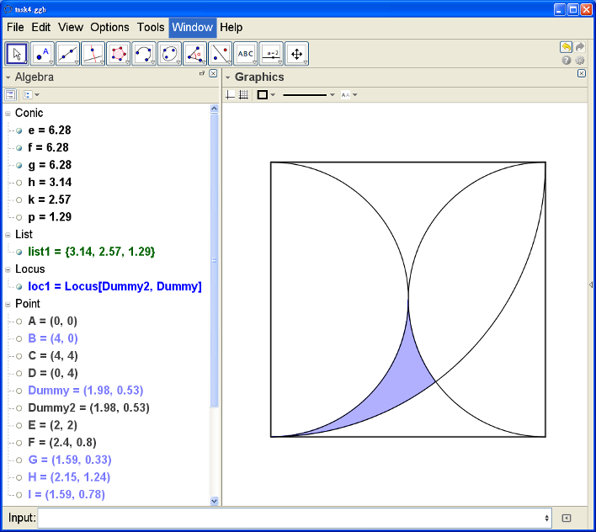
- Use the tools 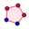,  and 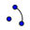 to draw the square, semi-circles and arcs as shown in the first figure.
- Create the five points E, F, G, H and I as shown in the second figure.
- Use the “Circumcircular Arc” tool 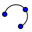 to draw the three arcs as shown in the third figure in the same, say anti-clockwise, direction.
- Input: list1={h,k,p} (where h, k, p are the names of the above three arcs).
- Input: Dummy=Point[list1]. You should get a free point which can be moved around the boundary of the enclosed region.
- Input: Dummy2=Dummy
- Input: Locus[Dummy2, Dummy]. You should get a locus object of which the color and opacity can be set.
- Hide all unnecessary objects.

Task 3 Clock with a Slider and Buttons

- Create a free point A. Set its colour yellow.
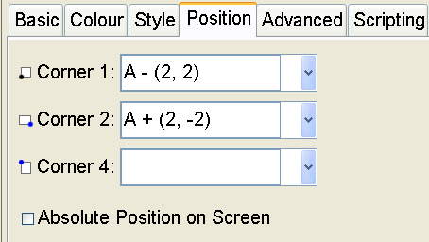
- Use the “Insert Image” tool 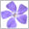. Click on A and select the given file “Clock_Face.jpg” to insert the picture of a clock face at A. Right-click the picture and choose “Object Properties”. In the “Position” tab, enter “A – (2, 2)” for Corner 1 and “A + (2, -2)” for Corner 2 as shown in the figure.
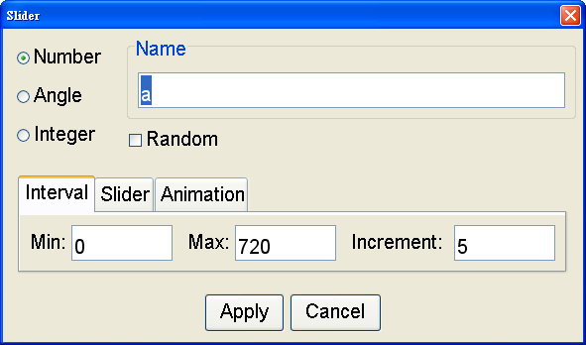
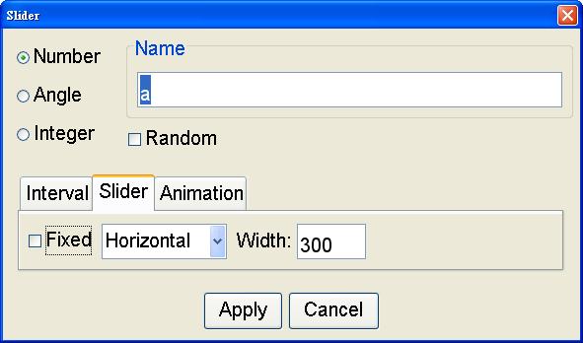
- Use the “Slider” tool to create a slider a which takes the value from 0 to 720 with increment 5. In the “Interval” and “Slider” tabs, enter the width 300 and uncheck the “Fixed” box as shown in the figures. Click “Apply”.
- Right-click the slider and choose “Object Properties”. In “Basic” tab, type “Move the hands” in the “Caption” field, and choose “Caption” in “Show Label”.
- Input:
P = Rotate[(0, 1.6), (-6)° a, A]
Q = Rotate[(0, 1.2), (-0.5)° a, A]
- Use the “Vector between Two Points” 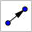 tool in the Line toolbox 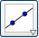. Click on the yellow point A and then P to draw the minute hand. Similarly click on A and then Q to draw the hour hand.
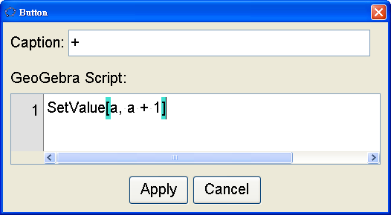
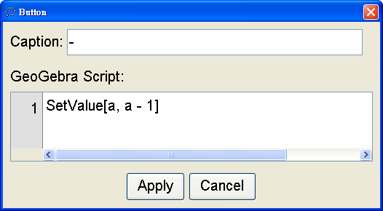
- Hide P and Q. Change the colours of the minute and hour hands to blue and red respectively. Change the “Line Thickness” of the hands to “13”.
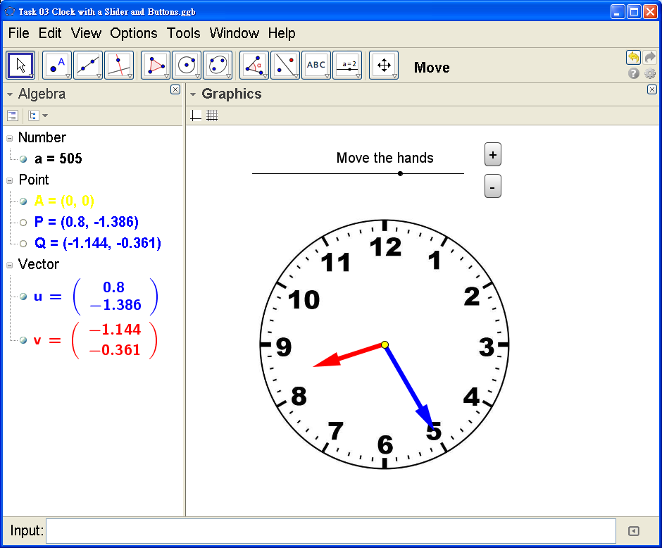
- Use the “Button” tool to create a button captioned “+” with GeoGebra Script
SetValue[a, a + 1]
and another button captioned “-” with GeoGebra Script SetValue[a, a - 1] .
- Drag the slider and click the buttons to move the hands of the clock.

Task 4 Creating Input Boxes and Drop-Down Lists

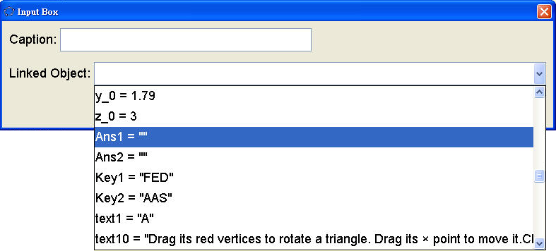
- Open the given file “AAS.ggb”.
- Use the “Input Box” 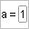 tool in the Action Object toolbox . Click on a position in the Graphics view. In the list of “Linked Object” choose “Ans1 = ""”, as shown in the figure. Click “Apply”.
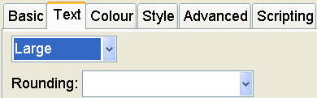
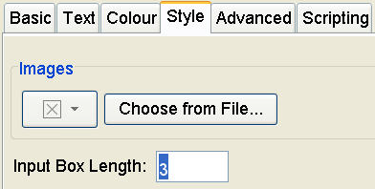
- Use the Move tool by pressing “Esc”. Right-click the label of the input box. Choose “Object Properties”. In the “Text” tab choose “Large”.
- Input FED in the input box.
Drag the input box to appropriate position. Right-click it and unselect “Show Label”.
(To move it again you need to show its label. Press “Ctrl+E” and select the input box in the window and show its label in the “Basic” tab.)
- Input: listAns2 = {"", "SSS", "SAS", "ASA", "AAS", "RHS"}
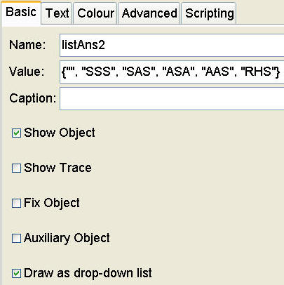
- Right-click “listAns2” in the Algebra view. Choose “Object Properties” and in the “Basic” tab check the “Draw as drop-down list” box.
- Choose “AAS” in the list. Right-click the label of the input box. Choose “Object Properties”. In the “Text” tab choose “Large”. Drag it to appropriate position. Right-click it and type “_” in the “Caption” field.
- Input: Ans2 = SelectedElement[listAns2]
- Close the Algebra view. Delete the content in the input box. Choose “” in the drop-down list.
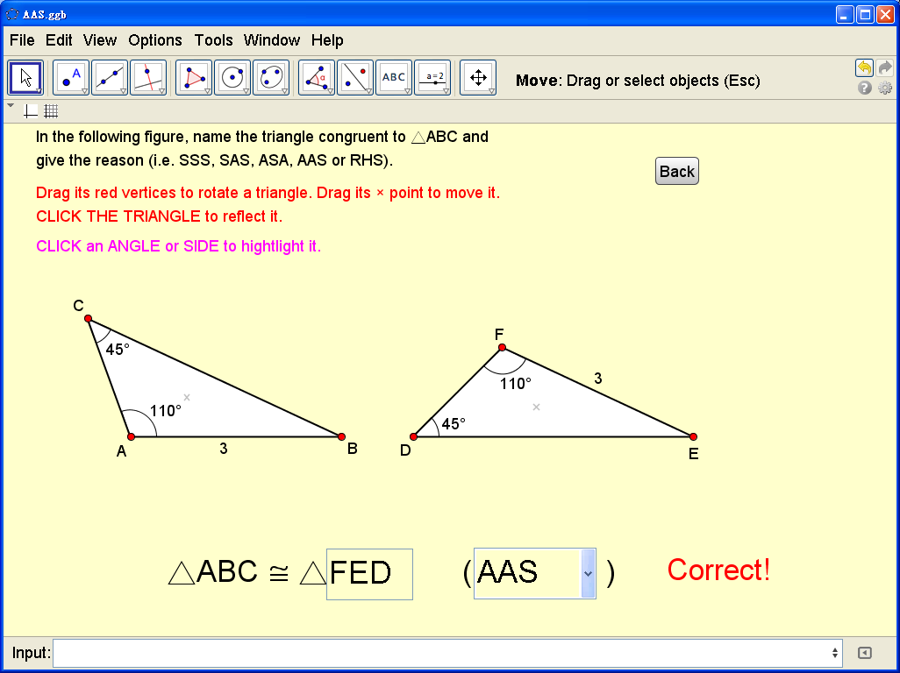
Task 5 Pinboard and Grid with Radio Buttons

- Create a slider n which takes the value from 3 to 9 with increment 1.
- Input: Sequence[Segment[(i, 0), (i, n)], i, 0, n]
This command creates the vertical lines of the grid.
- Input: Sequence[Segment[(0, i), (n, i)], i, 0, n]
This command creates the horizontal lines of the grid.
- Input: Sequence[Sequence[(i, j), i, 0, n], j, 0, n]
This command creates the dots of the pinboard.
- Create a checkbox named “Grid” to show/hide “list1” and “list2”, the vertical and horizontal grid lines.
- Create another checkbox named “Pinboard” to show/hide “list3”, the dots of the pinboard.
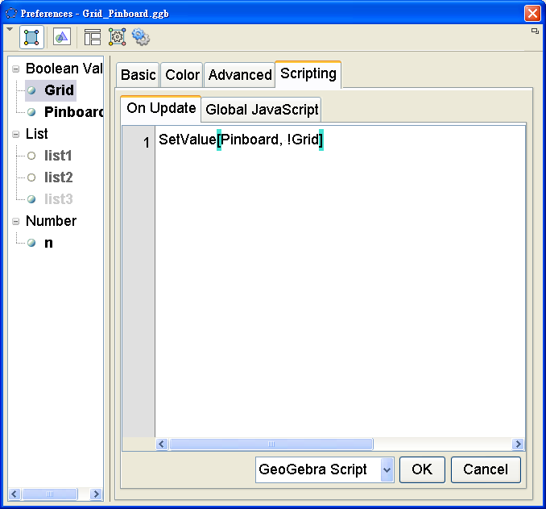
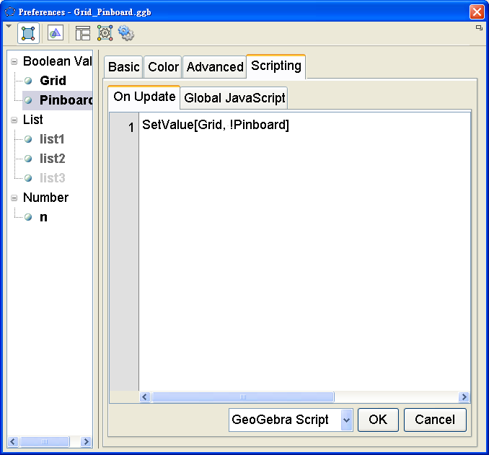
- Right-click the checkbox “Grid” and choose “Object Properties”. In the “Scripting” tab, enter the GeoGebra Script: SetValue[Pinboard, !Grid]
and click “OK”.
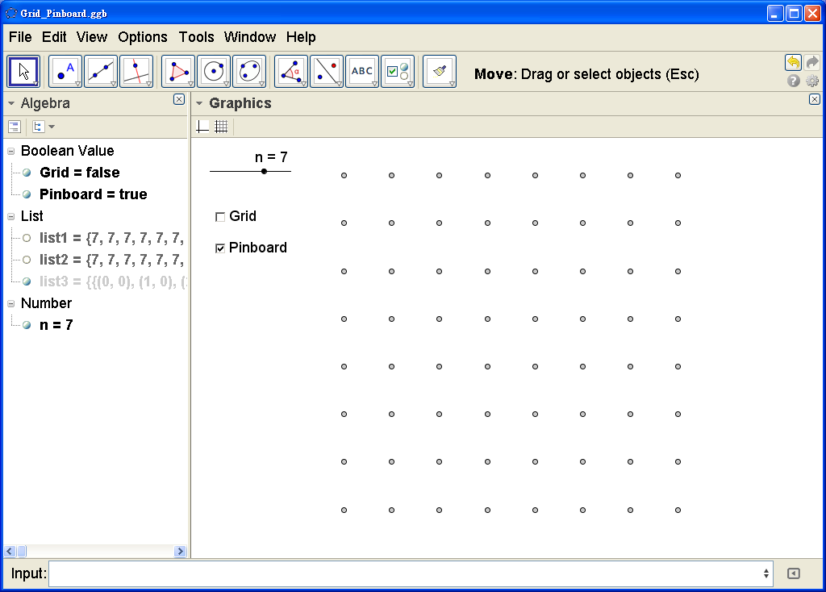
- Similarly, enter the GeoGebra Script: SetValue[Grid, !Pinboard]
for the checkbox “Pinboard”.
These two scripts turn the two checkboxes into radio buttons, i.e. only either one of them would be selected but not both.

Task 6 Definition of Slope

- Right-click in the Graphics view. Choose “Graphics …” and the “Grid” tab. Check the “Distance” box and set the distances of x and y both “1”.
- Choose “Options | Point Capturing | Fixed to Grid”.
- Using the line tool 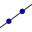, create a line passing through, say, (2,1) and (6,3).
- Input: C=If[x(B)>x(A),(x(B),y(A)), If[x(B)<x(A),(x(A),y(B))]]
Note that A, B and C always form a right-angled triangle.
- Input: deltaX=If[x(B)>x(A),Vector[A,C], If[x(B)<x(A),Vector[B,C]]]
Note that deltaX always points in positive-x direction.
- Input: deltaY=If[x(B)>x(A),Vector[C,B], If[x(B)<x(A),Vector[C,A]]]
Note that deltaY points in y direction.
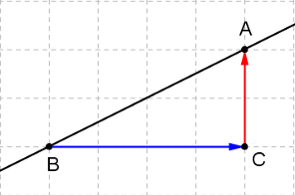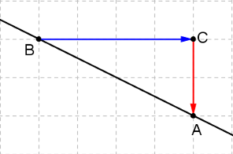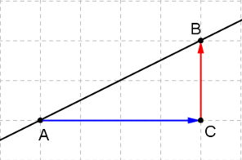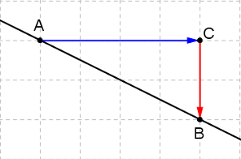
- Input: dx=deltaX*(1,0) (dot products of two vectors)
- Input: dy=deltaY*(0,1) (dot products of two vectors)
- Select the text tool 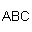, click anywhere in the Graphics view. Input the text as shown.
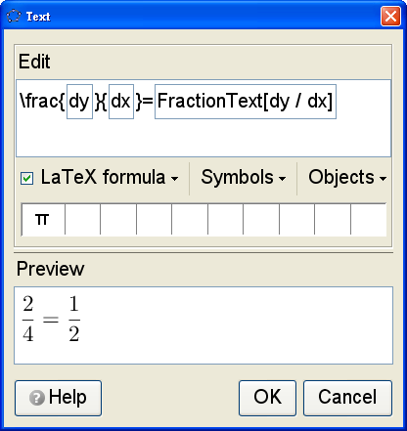
- Using the styling bar, set the text size and select “Absolute Position on Screen”.
- Hide the point C and the labels of A and B.
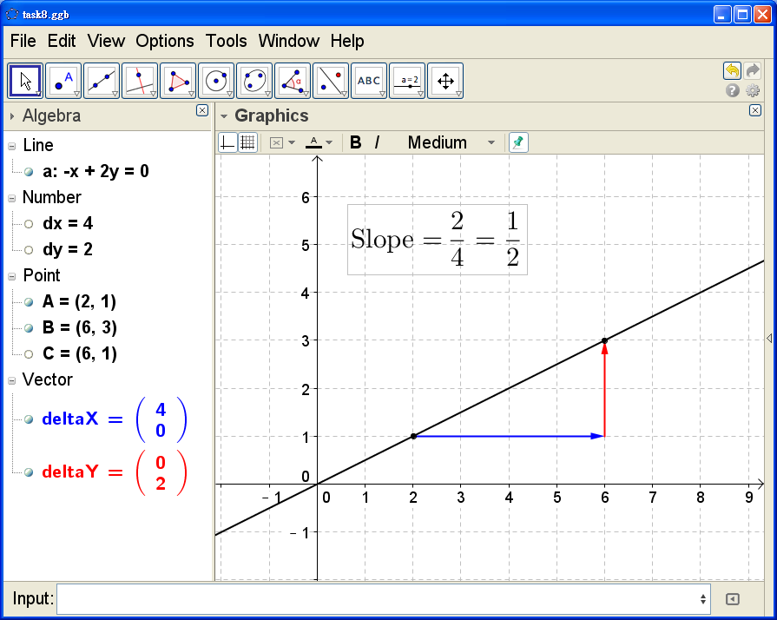

Task 7 Drawing a Ruler

- Input: A=(0,0)
- Input:
Polygon[A, A - (0.5, 0), A - (0.5, 2), A + (15.5, -2), A + (15.5, 0)]
to draw a rectangle.
- Input: Sequence[Segment[A + (i, 0), A + (i, -0.5)], i, 0, 15]
to draw the marks of the 1 cm divisions.
- Input:
Sequence[Segment[A + (i - 0.5, 0), A + (i - 0.5, -0.4)], i, 1, 15]
to draw the marks of the 5 mm divisions.
- Input:
Sequence[Sequence[Segment[A + (0.5i + 0.1j, 0), A + (0.5i + 0.1j, -0.3)], j, 1, 4], i, 0, 29]
to draw the marks of the 1 mm divisions.
- Input:
h=0.1
k=0.32
- Input: Sequence[A + (i, -0.5) - (h, k), i, 0, 16]
to create a list of points for positioning the numbers of the ruler.
- Input: Sequence[Text[i, Element[list4, i + 1], true], i, 1, 9]
to create the numbers 1 to 9 of the ruler.
- Input:
Sequence[Text[i, Element[list4, i + 1] - (h, 0), true], i, 10, 15]
to create the numbers 10 to 15 of the ruler.
- Input: Text["0", Element[list4, 1]]
to create the number 0 of the ruler.
- Hide list4 and point A. Colour all the lists in black.
- Hide the segments a and e. Input: Segment[A - (0.5, 0), A + (15.5, 0)]
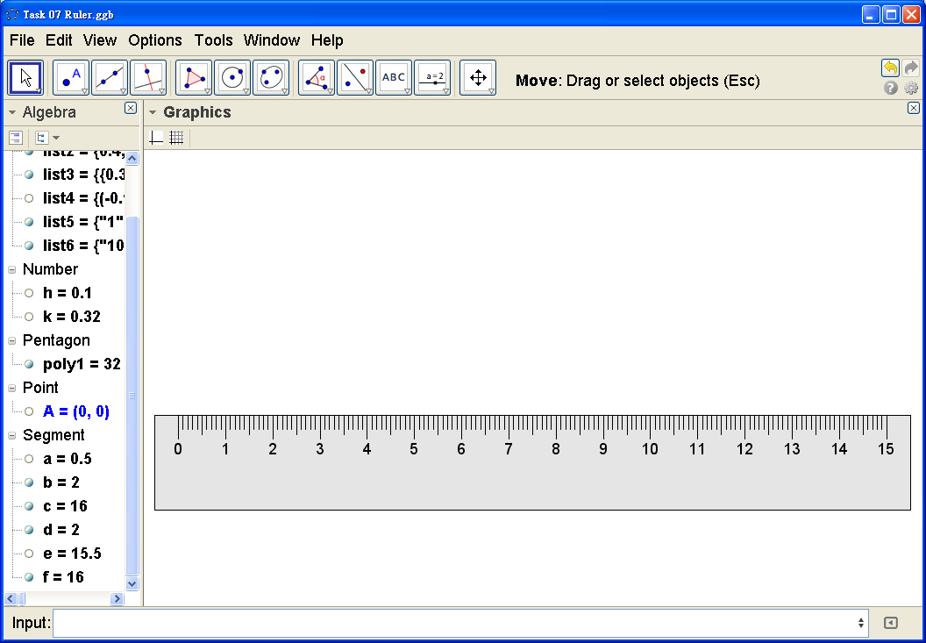
Task 8 Measuring the Length of a Variable Pencil using a Ruler

- Use the ruler drawn in the previous task. Use the Point tool 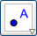 to create a new point B.
- Input: Point[Segment[B + (5, 0.5), B + (15, 0.5)]]
to draw a point C moving on a segment.
- Input: Polygon[B, C - (0, 0.5), C + (0, 0.5), B + (0, 1)]
to draw a variable polygon. Drag C to see how the polygon varies.
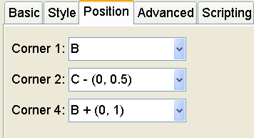
- Use the “Insert Image” tool in the Special Object toolbox 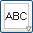. Click on B and select the given file “pencil.png” to insert the image of a pencil.
- Right-click the image and choose “Object Properties”. In the “Position” tab, enter the values of Corner 1, Corner 2 and Corner 4 as shown in the figure to specify the length and width of the pencil.
- Hide B. Change the colour of the polygon to white and make it transparent. Drag C to change the length of the pencil. Drag the pencil to suitable position to measure its length. Hide the label of C.
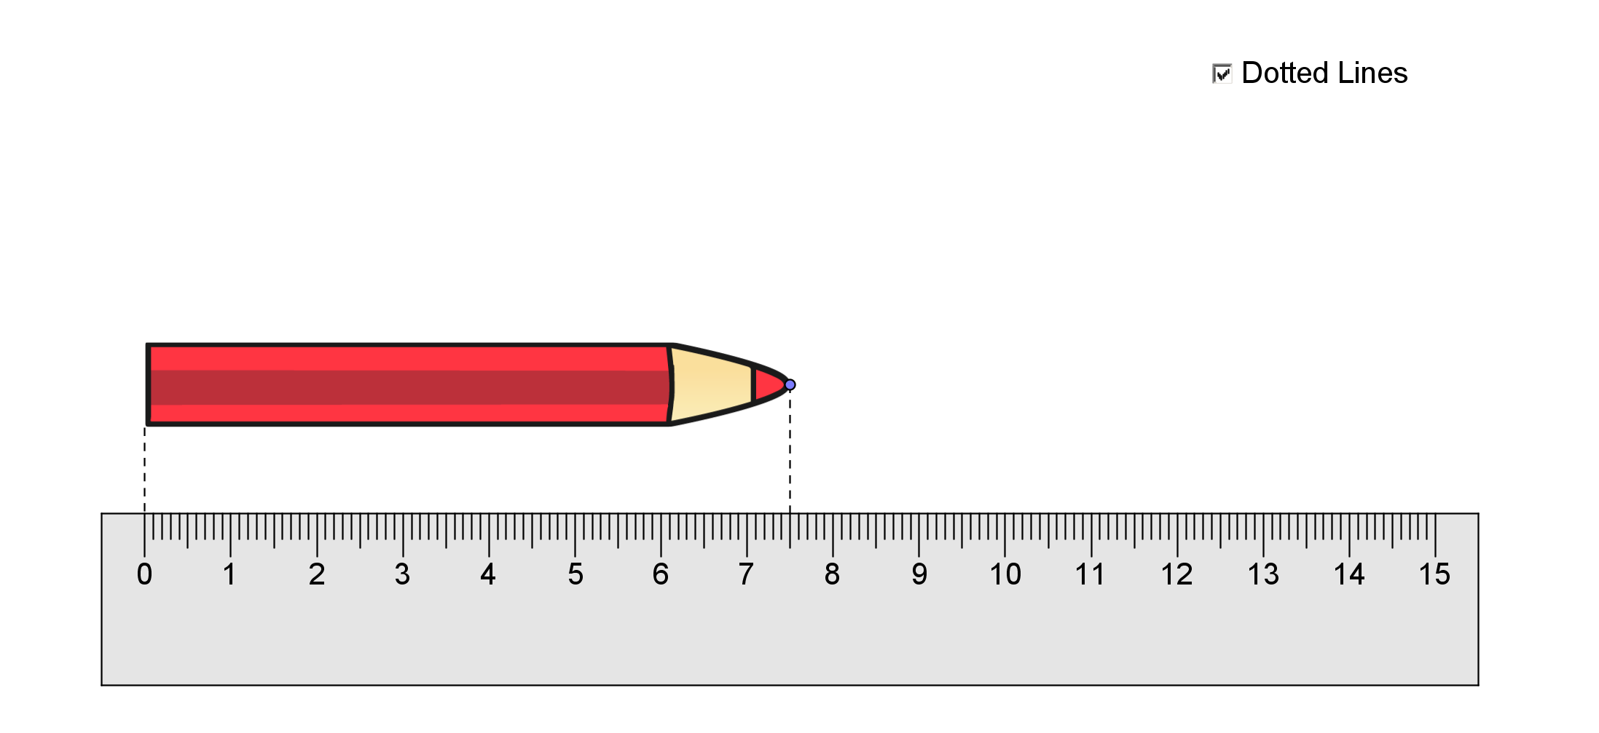
- Input: Segment[B, Intersect[PerpendicularLine[B, f], f]]
Segment[C, Intersect[PerpendicularLine[C, f], f]]
to draw two lines from the ends of the pencil perpendicular to the ruler. (Note: f is the upper side of the ruler.) Change the style of these two lines to , as shown in the figure.
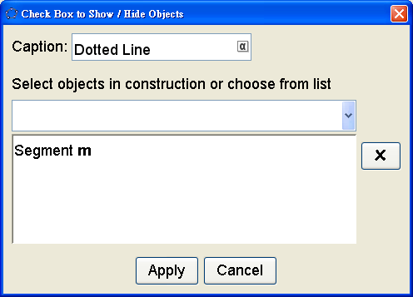
- Use the “Check Box”  tool in the Action Object toolbox . Click on a position. Enter “Dotted Lines” in the “Caption” field. Click on the dotted line at the head (Segment m). Click “Apply”.
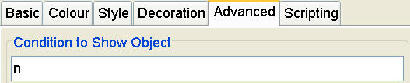
- Right-click the other dotted line and choose “Object Properties”. In the “Advanced” tab, type “n” (name of the checkbox captioned “Dotted Lines”) so that the checkbox also control the “Show/Hide” of this dotted line.
- Drag the pencil to suitable position to measure its length. To secondary students, discuss the maximum error of measurement, using the tools “Zoom In”  (mouse wheel down) and “Zoom Out”  tool (mouse wheel up) in the 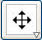 toolbox.
Task 9 Tracing the Centre of a Circle Passing thorough Two Fixed Points

- In the Menu, choose “Options | Point Capturing | Off”. Hide the axes and grid.
- Create two points A and B.
- Use the 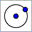 tool to draw a circle of centre C and passes through D. Colour C and D in red.
- Draw the dotted line segments CD.
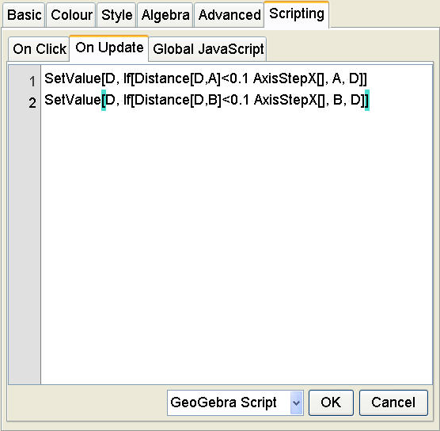
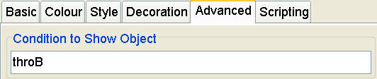
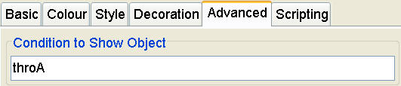
- Right-click on D. Go to “Object Properties | Scripting | On Update”, enter:
SetValue[D, If[Distance[D,A]<0.1 AxisStepX[], A, D]]
SetValue[D, If[Distance[D,B]<0.1 AxisStepX[], B, D]]
Click “OK”. D would be captured to A or B when they get close.
- Input: diff = abs(Distance[C, A] - Distance[C, B])
- Drag D to A. Draw the dotted line segment CB. Input:
throB = D == A && diff <= 0.02 AxisStepX[]
- Right-click the segment CB. Go to “Object Properties | Advanced”. In the “Condition to Show Object” field enter: throB
- Drag D to B. Draw the dotted line segment CA. Input:
throA = D == B && diff <= 0.02 AxisStepX[]
- Right-click the segment CA. Go to “Object Properties | Advanced”. In the “Condition to Show Object” field enter: throA
- Input:
C’ = Intersect[PerpendicularBisector[A, B], PerpendicularLine[C, PerpendicularBisector[A, B]]]
- Colour C’ in red. Hide the labels of D and C'.
- Create the checkbox named “showTrace” and captioned “Show Trace”. Right-click it and go to “Object Properties | Scripting | On Update”, enter: ZoomIn[1]
- Right-click C' and go to “Object Properties | Advanced”. In the “Condition to Show Object” field enter: showTrace && diff <= 0.02 AxisStepX[] && (throA || throB)
- In the Algebra view, right-click C’ and choose “Trace On”.
- Check the “Show Trace” box. Drag the red point to either A or B. Drag C so that the circle passes through the other point and see its locus.
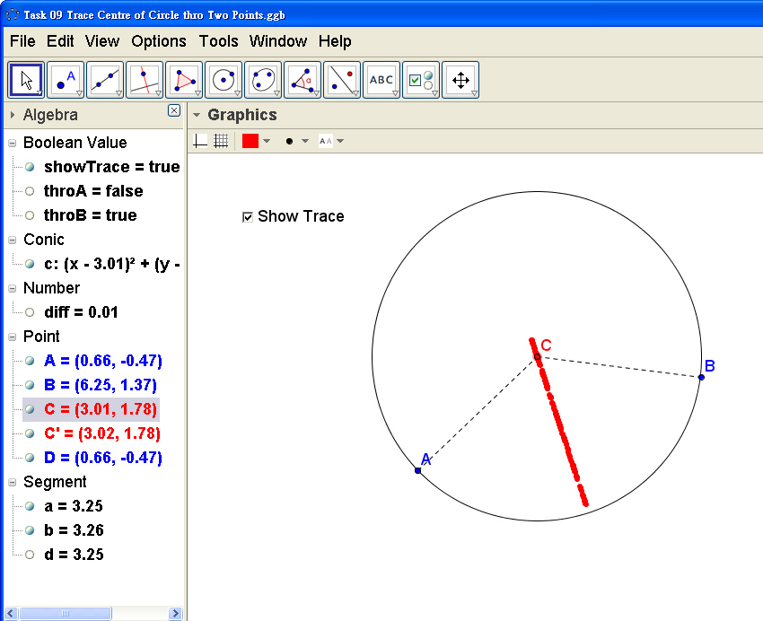
Task 10 Polar Coordinate Quiz

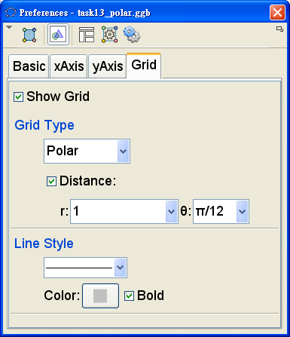
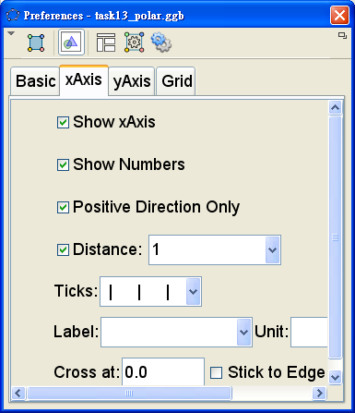
- Change the grid to “Polar” with distance and . Use solid and bold grid lines. Hide y-axis and show positive x-axis.
- Input: r=RandomBetween[1,8]
- Input: listAngle=Sequence[15°*i,i,0,23]
(Hint: press Alt-o for °)
- Input: theta=RandomElement[listAngle]
- Input: P=(r;theta)
- Input: Ans=(0;0°)
- Input: correct=Ans==P
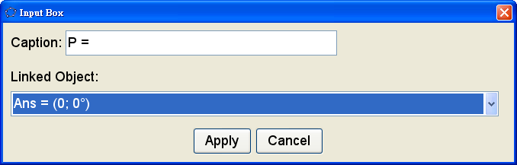
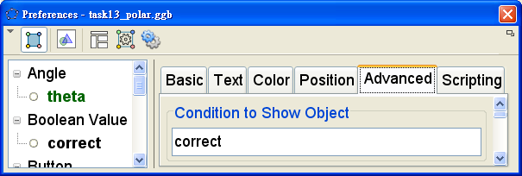
- Select the input box tool 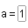. Create an input box with caption “P =” and choose “answer” as the linked object.
- Select the text tool . Create a text “Correct!” and set “Condition To Show Object” “correct”.
- Create a button  with caption “Next Point”. Type the following on-click scripts:
SetValue[Ans,(0;0°)]
UpdateConstruction[]
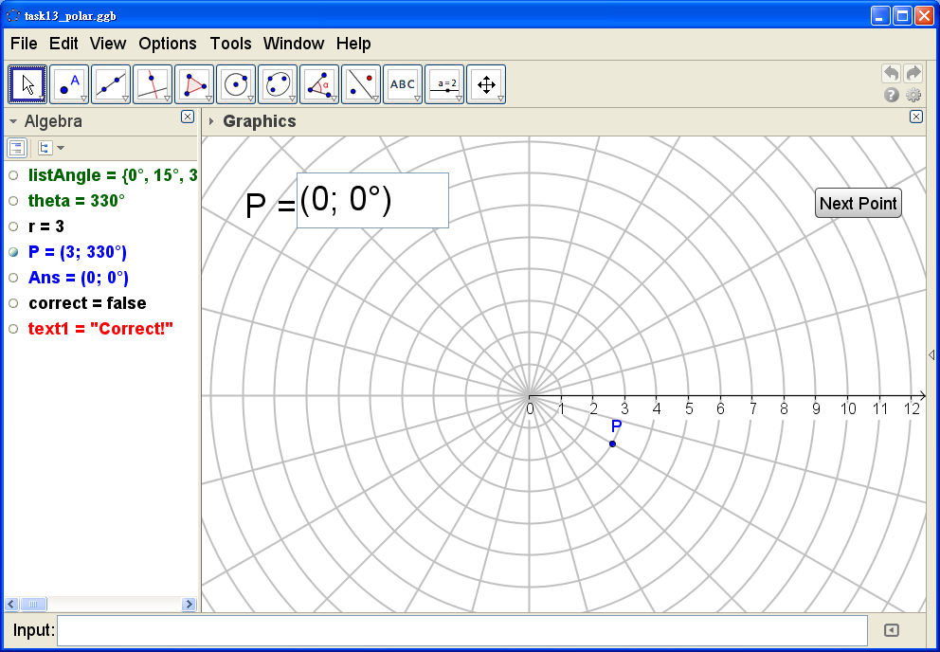
Task 11 Customized Tool: Median of Triangle

- Use to create a free point A. Input: Segment[(0,0), (4,2)]
- Input: Midpoint[a]
Segment[A,B]
Segment[B, B + a / 2 UnitVector[a]]
Segment[B, B - a / 2 UnitVector[a]]
- Label segments c and d by their values.
- In the Menu, choose “Tools | Create New Tools”.
In the “Output Objects” tab select the objects as shown in the first figure from the Graphics view. Click “Next”.
- In the “Input Objects” view, select the objects as shown in the second figure. Click “Next”.
- In the “Name & Icon” tab, enter the “Tool name”, “Command name” and “Tool help” as shown in the third figure.
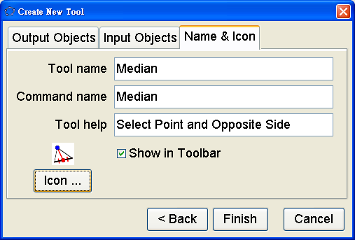
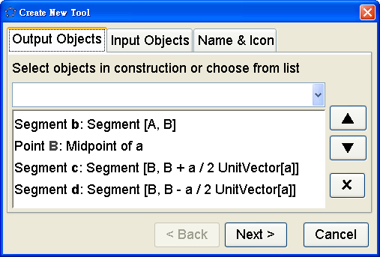
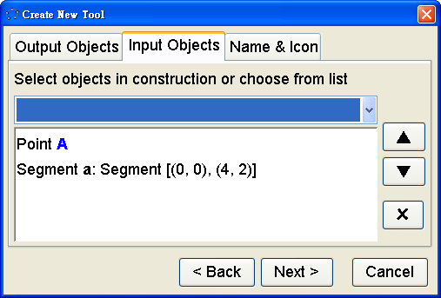
- Click the “Icon” button. Select the given image “Median.png” as the icon of the tool. Click “Finish”.
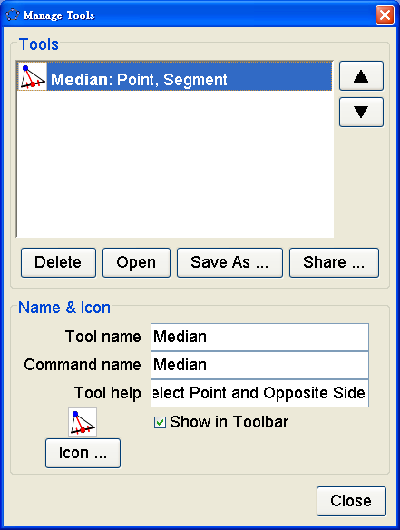
- In the menu, choose “Tools | Manage Tools”. Click “Save as” to save the tool as “Median.ggt”.
- Close this file and GeoGebra. Double-click the file “Median.ggt”. A blank GeoGebra window would be opened with the “Median” tool 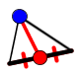 added in the toolbar.
- Draw a triangle. Use the “Median” tool to draw the two medians at A and B. Input the command: Median[C, c] to draw the median at C.
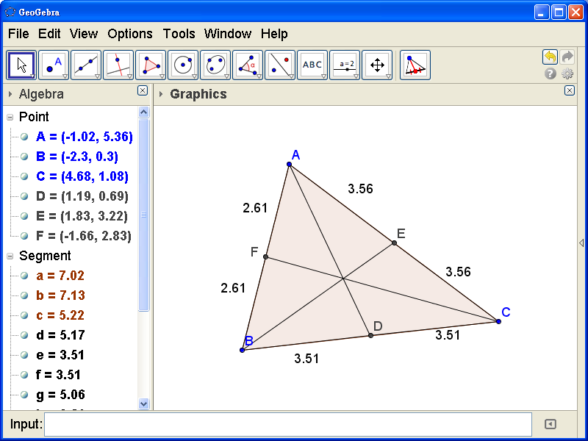

Task 12 A Multiple-Control Movable, Rotatable and Changeable Triangle)
(Adapted from rami's “Polygon: drehen, bewegen, verändern” in GeoGebraTube: http://ggbtu.be/m1363)

- Draw a triangle ABC and a free point P.
- Input: t = false
angle = 0°
u = Vector[P, A]
v = Vector[P, B]
w = Vector[P, C]
- Caption the checkbox t by “Change Shape and Position”.
- Right-click on A. Go to “Object Properties | Scripting | On Update”, enter:
SetValue[angle, Angle[u, Vector[P, A]]]
SetValue[A, If[!t, P + Rotate[u, angle], A]]
SetValue[B, If[!t, P + Rotate[v, angle], B]]
SetValue[C, If[!t, P + Rotate[w, angle], C]]
Click “OK”.
- Right-click on B. Go to “Object Properties | Scripting | On Update”, enter:
SetValue[angle, Angle[v, Vector[P, B]]]
SetValue[A, If[!t, P + Rotate[u, angle], A]]
SetValue[B, If[!t, P + Rotate[v, angle], B]]
SetValue[C, If[!t, P + Rotate[w, angle], C]]
Click “OK”.
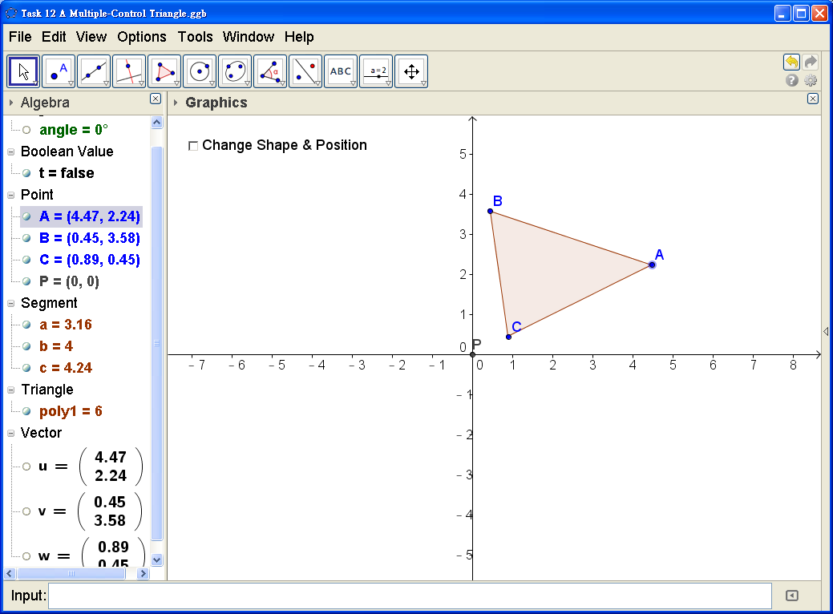
- Right-click on C. Go to “Object Properties | Scripting | On Update”, enter:
SetValue[angle, Angle[w, Vector[P, C]]]
SetValue[A, If[!t, P + Rotate[u, angle], A]]
SetValue[B, If[!t, P + Rotate[v, angle], B]]
SetValue[C, If[!t, P + Rotate[w, angle], C]]
Click “OK”.
- Drag P to any position. Drag A, B, C, the triangle or any one of the three sides to rotate △ABC about P.
Check the box “Change Shape and Position” to change the shape or position of the triangle.
Uncheck the box to rotate the triangle about P again.

Task 13 Using Recursion in Spreadsheet to Construct Sierpinski Triangle
(Adapted from jcsantos's “Sierpinski Triangle” in GeoGebraTube: http://ggbtu.be/m6189)

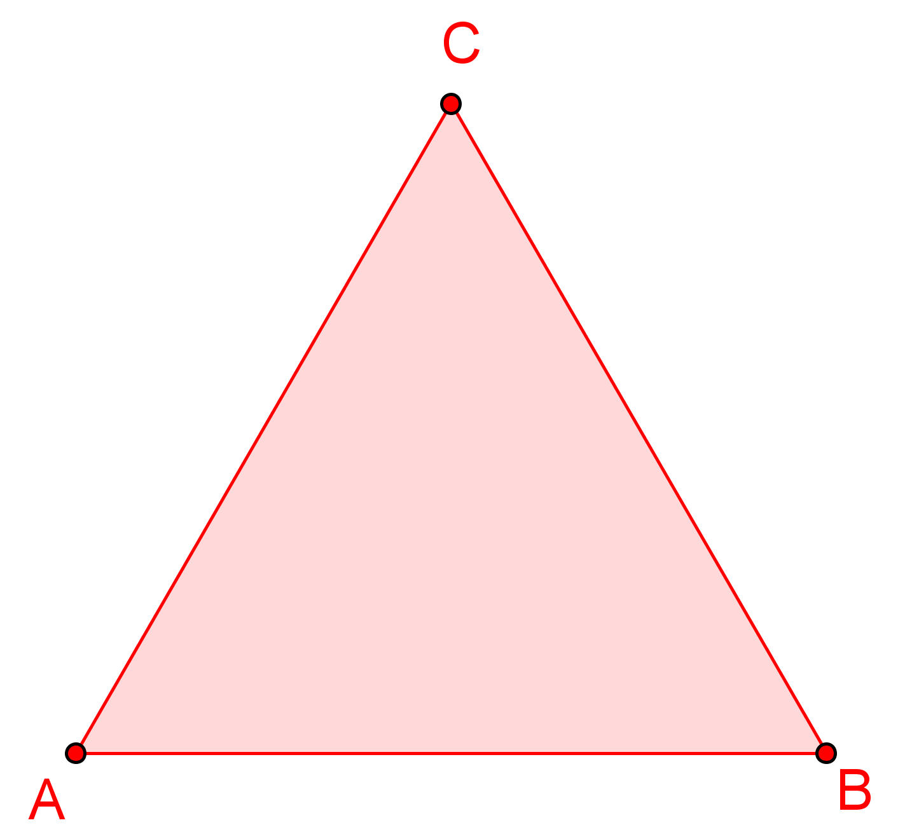
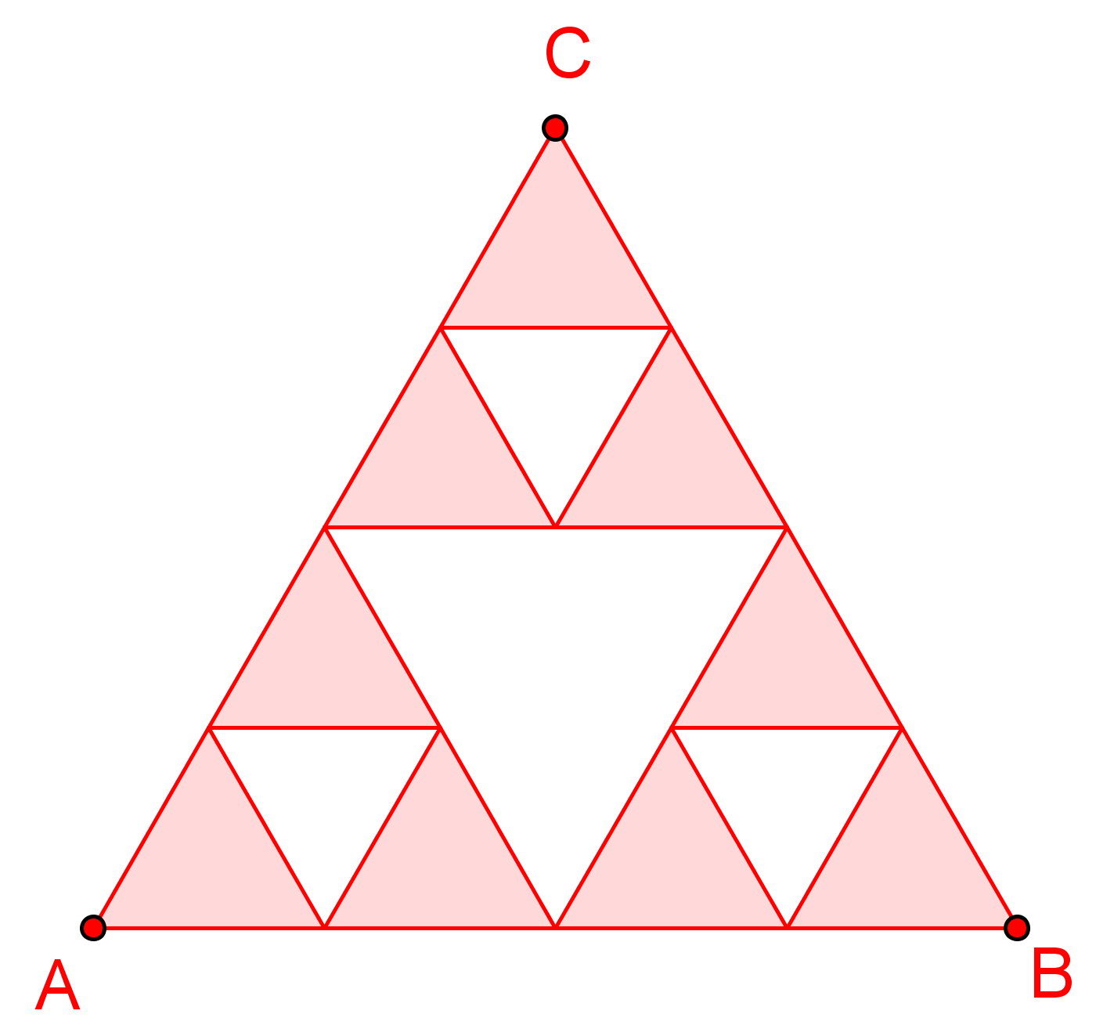
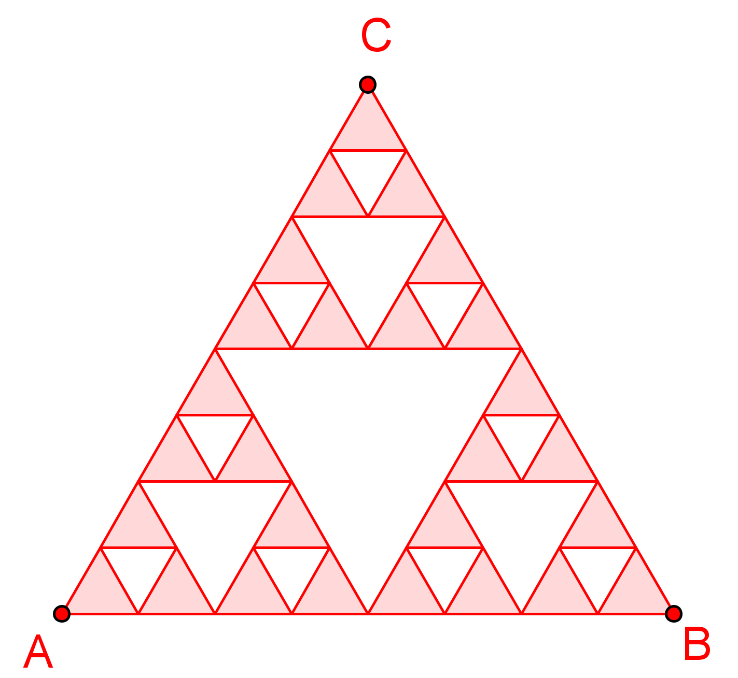
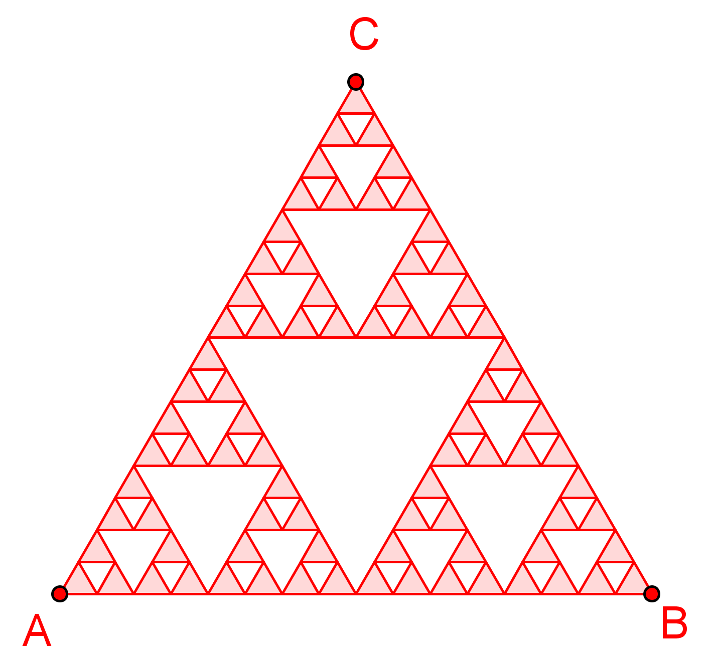
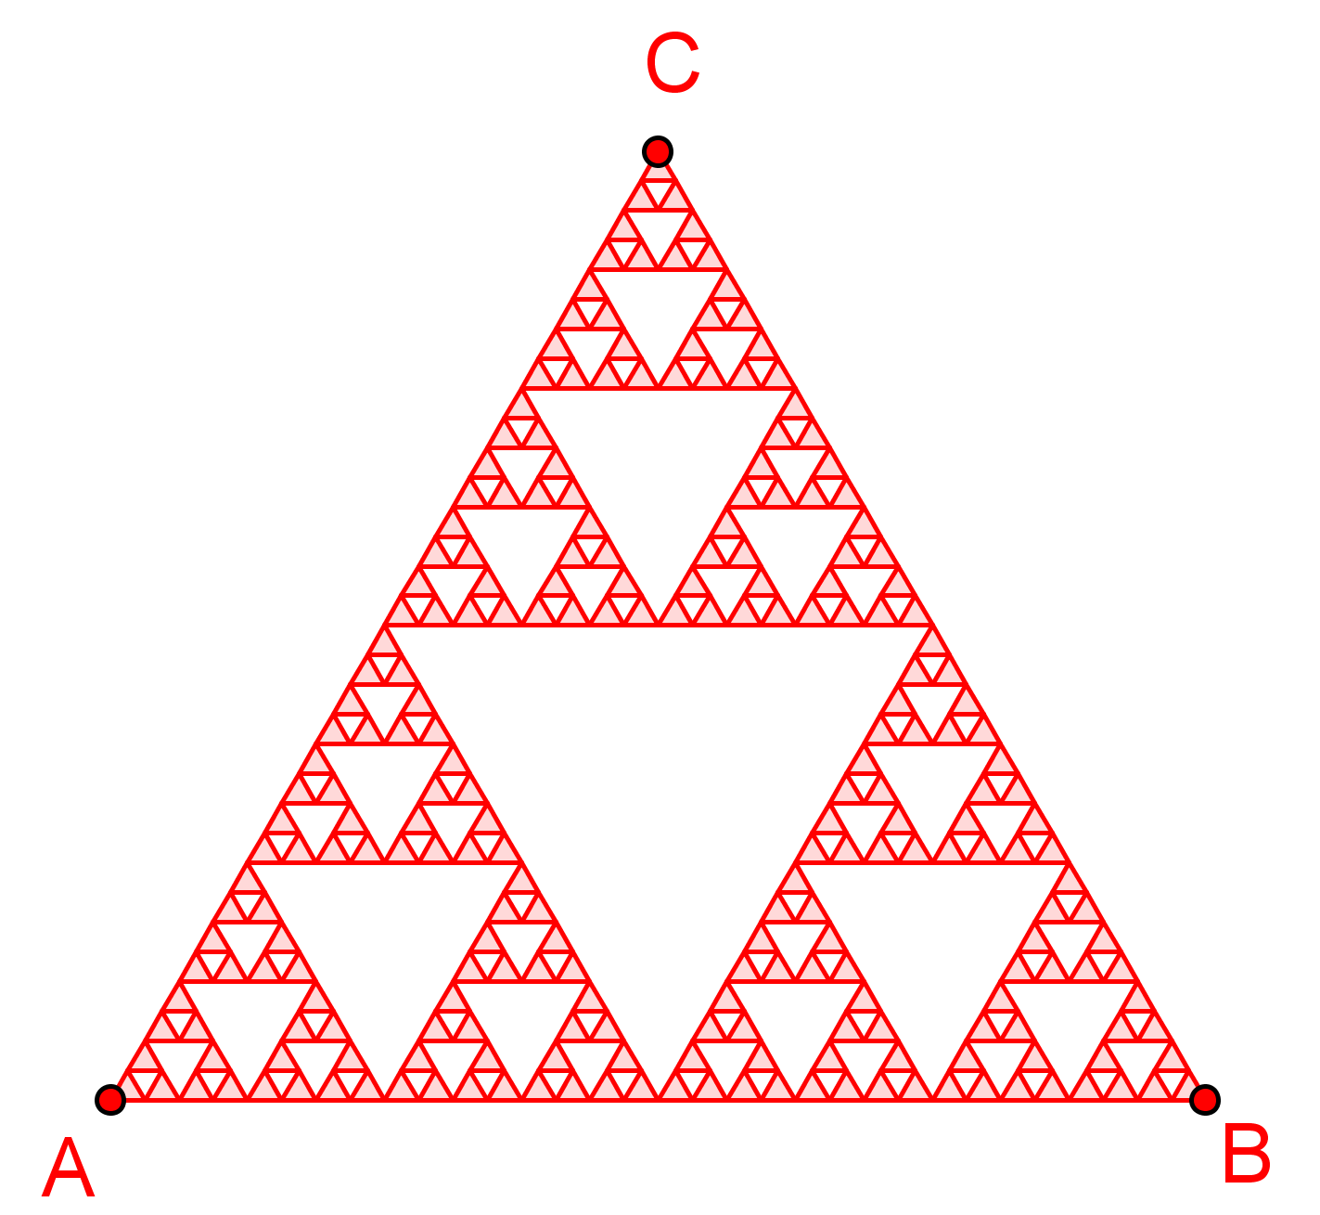
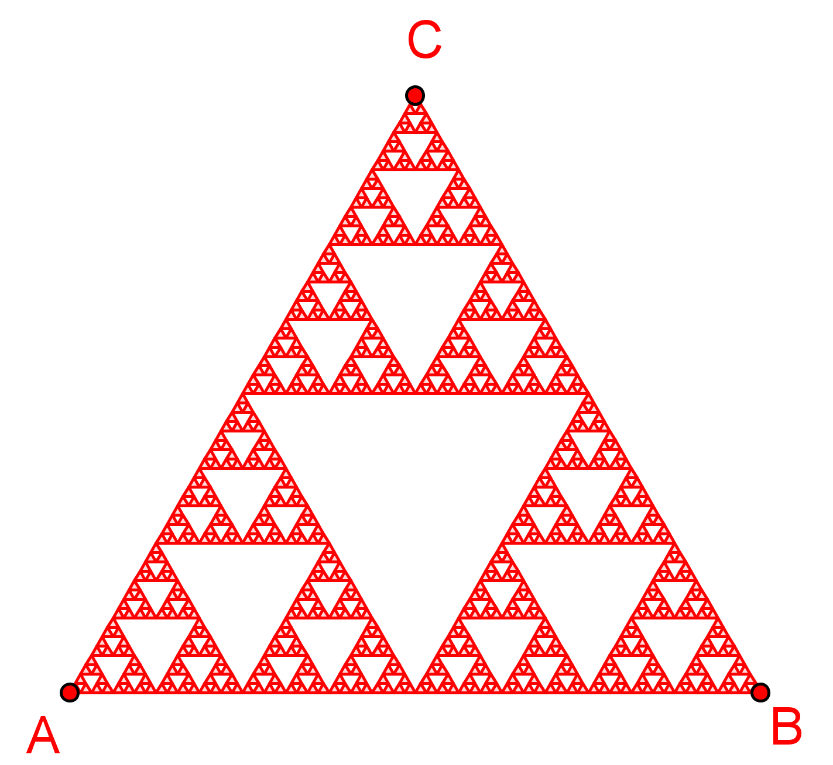
- Show the Spreadsheet view.
- Construct three points A, B and C so that △ABC is an equilateral triangle.
- Input:
A1 = {{A, B, C}}
B1 = Polygon[Element[A1, 1]]
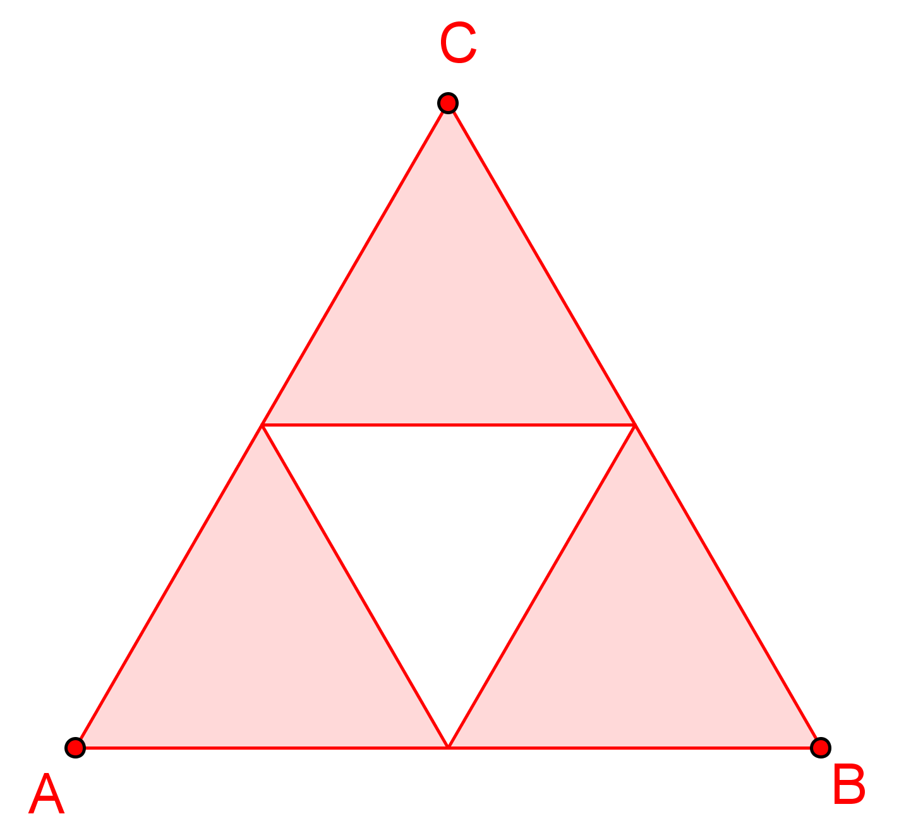
- Input:
A2 = {{A, Midpoint[A, B], Midpoint[A, C]}, {B, Midpoint[B, A], Midpoint[B, C]}, {C, Midpoint[C, A], Midpoint[C, B]}}
B2 = Sequence[Polygon[Element[A2, i]], i, 1, 3]
- Type in the input bar (do NOT press enter):
A3 = Join[Sequence[{{}, {}, {}}, i, 1, Length[A2]]]
- In the 1st braces type (do NOT press “Enter”):
Element[Element[A2,i],1], Midpoint[Element[Element[A2,i],1],Element[Element[A2,i],2]], Midpoint[Element[Element[A2,i],1],Element[Element[A2,i],3]]
- In the 2nd braces type (do NOT press “Enter”):
Element[Element[A2,i],2], Midpoint[Element[Element[A2,i],2],Element[Element[A2,i],1]], Midpoint[Element[Element[A2,i],2],Element[Element[A2,i],3]]
- In the 3rd braces type (do NOT press “Enter”):
Element[Element[A2,i],3], Midpoint[Element[Element[A2,i],3],Element[Element[A2,i],1]], Midpoint[Element[Element[A2,i],3],Element[Element[A2,i],2]]
Press “Enter” afterwards.
- Enter:
B3 = Sequence[Polygon[Element[A3, i]], i, 1, Length[A3]]
- Select A3 and B3 in the spreadsheet view. Drag them down to produce A4 and B4; A5 and B5; A6 and B6 and A7 and B7.
- Hide the lists from A1 to A7.
- Create a slider named n which takes the values from 1 to 7.
- Set condition show of B1 to B7 for n = 1 to 7 respectively.
- Set B1 to B7 in red.
Extra Task 1: The Symmetry Ruler
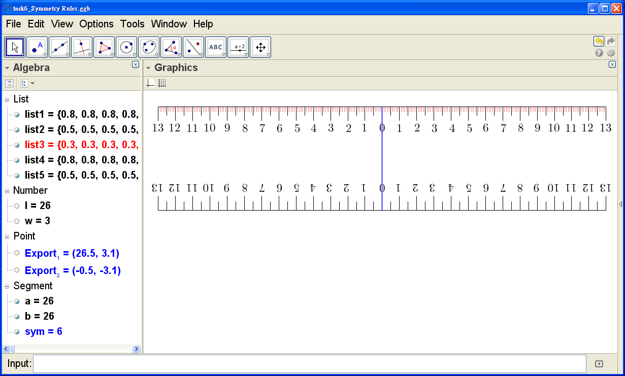
- Input: l=26
- Input: w=3
- Input: Sequence[Segment[(i,w-0.8),(i,w)], i, 0, l]
Thickness=2, Color=Black, Layer=1
- Input: Sequence[Segment[(i,w-0.5),(i,w)], i, 0, l, 0.5]
Thickness=2, Color=Black, Layer=1
- Input: Sequence[Segment[(i,w-0.3),(i,w)], i, 0, l, 0.1]
Thickness=1, Color=Red, Layer=0
- Input: Reflect[list1, xAxis]
- Input: Reflect[list2, xAxis]
- Input: a=Segment[(0,w),(l,w)]
Thickness=2, Color=Black
- Input: b=Segment[(0,-w),(l,-w)]
Thickness=2, Color=Black
- Input: sym=Segment[(l/2,w),(l/2,-w)]
Thickness=3, Color=Blue, Layer=3
- Input: “13” (Move the text to the right place.)
- Input: RotateText["13", 180°] (Move the text to the right place.)
- Create the other similar texts. Move them to the right places carefully.
- Input: Export_1=(l+0.5,w+0.1) (Hide the point.)
- Input: Export_2=(-0.5,-w-0.1) (Hide the point.)
- Hide the grid and axes. Export the Graphic View as eps format (1:1) to Clipboard.
Paste it into Microsoft Word.
Extra Task 2: Difference of Squares

- Right-click in the Graphics view. Choose “Graphics …” and the “Grid” tab. Check the “Distance” box and set the distances of x and y both “1”. Choose solid bold line style.
- Using the point tools 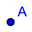, create the points A(0,0) and B(8,0).
- Select the regular polygon tool . Click A then B. Input 4 for vertices. A square ABCD is created.
- Input: E=Point[a] to create a point of the side AB.
- Select regular polygon tool 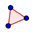. Click E then B. Input 4 for vertices. A square EBFG is created.
- Hide the two squares.
- Input: H=(0,y(G))
- Select the polygon tool . Create two rectangles AEGH and HFCD as shown.
- Select the slider tool 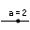. Create a slider k of values from 0 to 1 with 0.01 increments. Hide its label.
- Select the dilation tool 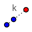. Click C then A. Input k for the factor. An image point C’, which runs from A to C depending on the value of k, should appear.
- Select the vector tool 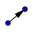. Create a vector from A to C’.
- Select the translation tool 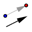. Click the rectangle AEGH then the vector AC’. An image rectangle A’E’G’H’ is created, which can be moved by the slider.
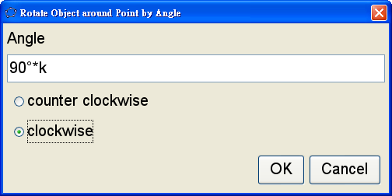
- Select the rotation tool 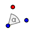. Click the rectangle A’E’G’H’ then C’. Enter the angle as shown. An image rectangle A’’E’’G’’H’’ is created.
- Hide the vector AC’ and the rectangles AEGH and A’E’G’H’, leaving HFCD and A’’E’’G’’H’’.
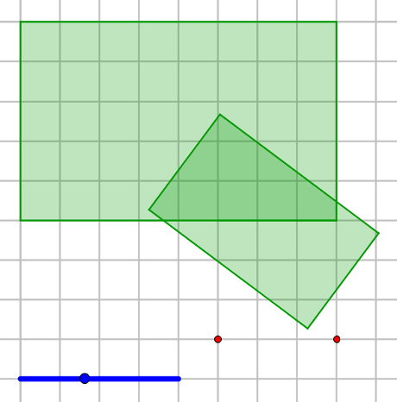
- Choose “Options | Algebra Descriptions | Command”.
Click also 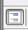 to show also auxilury objects.
- In Algebra view, find the segment joining H and F, set “Condition to Show Object” “k>0”.
- In Algebra view, find the segment joining H’’ and G’’, set “Condition to Show Object” “k>0”.
- Show the segment joining F and G.
- Hide all points except B and E. Hide the labels of B and E.
- Hide the axes. Adjust colors, line thickness, opacity, etc as you like.
Extra Task 3: Koch Snowflake
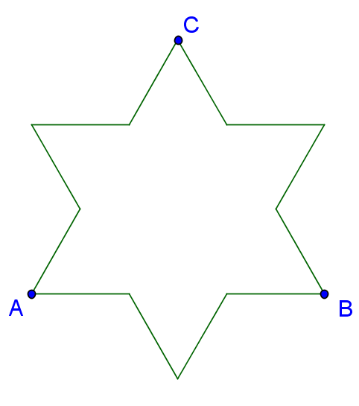
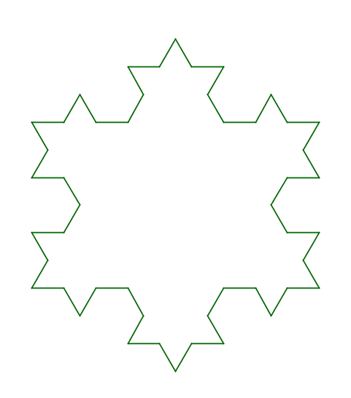
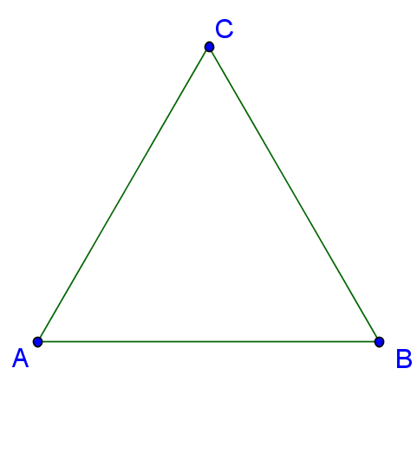

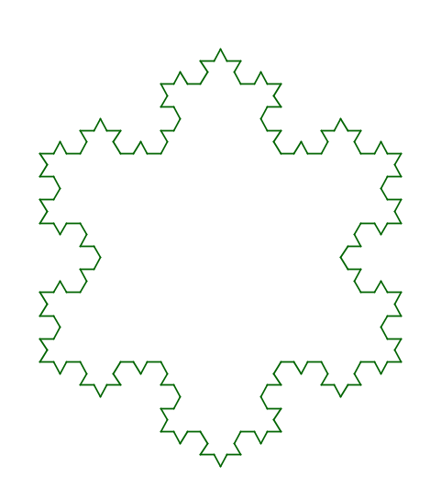
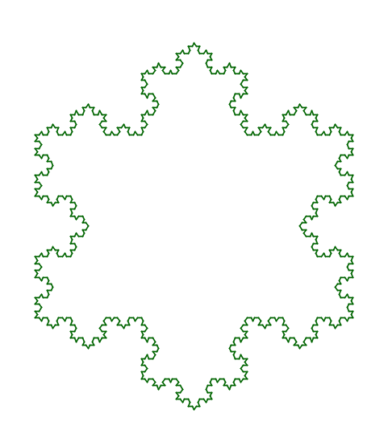
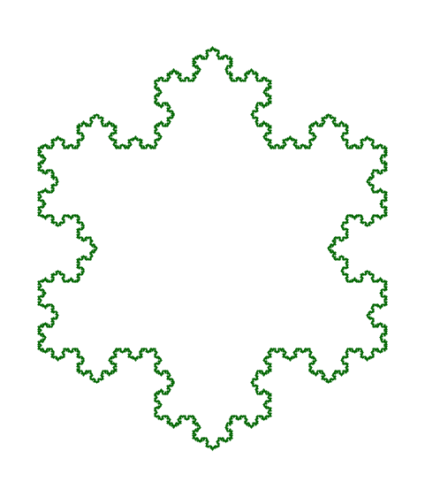

- Show the Spreadsheet view.
- A = (0, 0)
- B = (10, 0)
- C = Rotate[B, 60°, A]
- A1 = {{A, B}, {B, C}, {C, A}}
- B1 = Sequence[Segment[Element[Element[A1, i], 1], Element[Element[A1, i], 2]], i, 1, Length[A1]]
- A2 = Join[Sequence[{{}, {}, {}, {}}, i, 1, Length[A1]]]
where content in 1st {}: A, 2/3 A+1/3 B
where content in 2nd {}: 2/3 A+1/3 B, Rotate[1/3 A+2/3 B, 300°, 2/3 A+1/3 B]
where content in 3rd {}: Rotate[1/3 A+2/3 B, 300°, 2/3 A+1/3 B], 1/3 A+2/3 B
where content in 4th {}: 1/3 A+2/3 B, B
AND replace A by: Element[Element[A1, i], 1]
AND replace B by: Element[Element[A1, i], 2]
- Hide A, B and C.
- Select A2 and drag it down to produce A3, A4, A5 and A6.
- Hide the lists from A1 to A6.
- Select B1 and drag it down to produce B2, B3, B4, B5 and B6.
- Create a slider named n which takes the values from 1 to 6.
- Set condition show of B1 to B6 for n = 1 to 6 respectively.
Extra Task 4: Area of a Circle
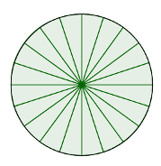
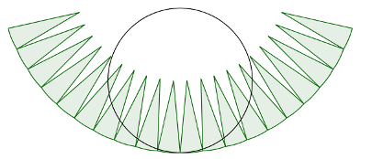
- cir=Circle[(0,1),1]
- k=Slider[0,2,0.01]
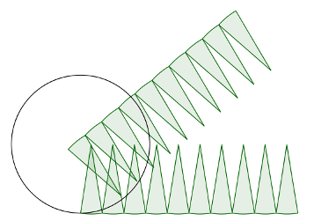
- n=Slider[3,100,1]
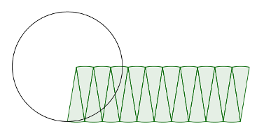
- s=If[k<1,k,1]
- t=If[k<1,0,k-1]
- A=(0,1/(1-s))
- circumPoints=Sequence[Rotate[(0,0),pi*(1-s)i/n,A],i,-n,n]
- centrePoints=Sequence[Intersect[Circle[Element[circumPoints,i],1],Circle[Element[circumPoints,i+1],1]],i,1,2n]
- sector=Sequence[CircularSector[Element[centrePoints,i],Element[circumPoints,i],Element[circumPoints,i+1]],i,1,2n]
- circumStraight=Sequence[(-pi+pi*i/n,0),i,0,2n]
- centreStraight=Sequence[Intersect[Circle[Element[circumStraight,i],1],Circle[Element[circumStraight,i+1],1]],i,1,2n]
- sectorL=Sequence[CircularSector[Element[centreStraight,i],Element[circumStraight,i],Element[circumStraight,i+1]],i,1,n]
- sectorR=Reflect[sectorL,yAxis]
- sectorRotateL=Rotate[sectorL,(-180t)°,Midpoint[Element[centreStraight,n+1],(0,0)]]
- SetConditionToShowObject[sectorR,k>=1]
- SetConditionToShowObject[sectorRotateL,k>=1]

In Algebra view, hide the objects cicumPoints, centrePoints, circumStraight, centreStraight, sectorL and point A.
Hide the axis and grid lines. Adjust the colours, opacity, line thickness, etc as you like. Move the sliders.

Reference: http://www.geogebratube.org/material/show/id/27562

