Where are these schools located? All over the UK
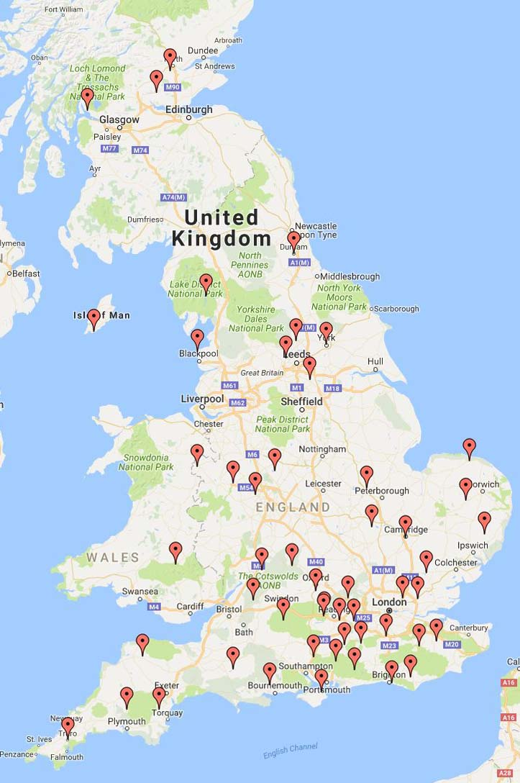
A SCHOLARSHIP FOR TWO YEARS IN A BRITISH BOARDING SCHOOL
with HMC Projects in Central and Eastern Europe

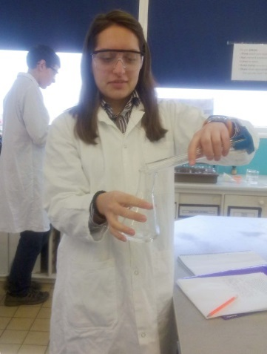
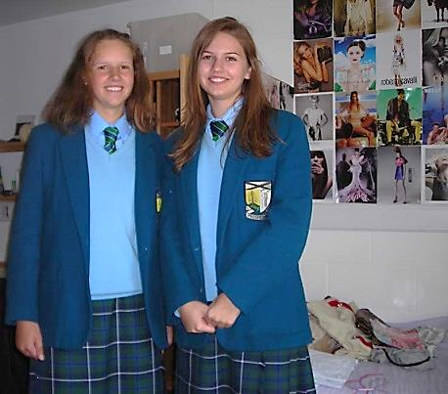
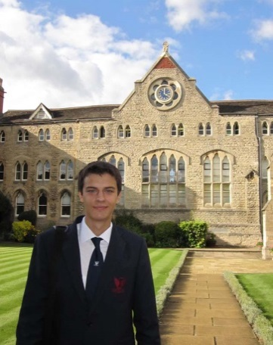
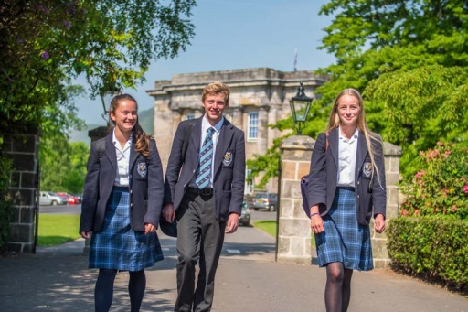
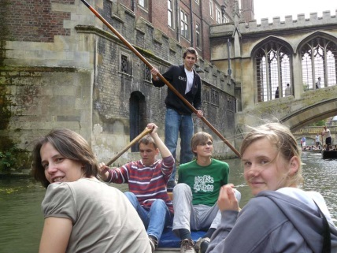
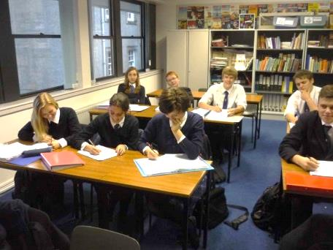
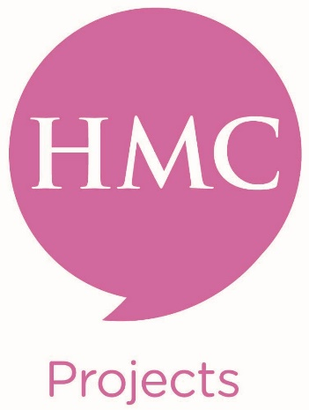
British boarding schools are amongst the very best schools in the world….
HMC Projects is a charitable trust which organises two scholarship programmes for very bright and able 16/17 year-olds in 14 countries in Central and Eastern Europe. It takes about 90 scholars each year and places them in some 60 boarding schools in all parts of the UK, so that they can study for the full two-year Sixth Form programme and take internationally recognised qualifications (A Levels, the International Baccalaureate or Scottish Highers).
Could you win a scholarship?
- Are you bright, able, adaptable, different, ambitious, interesting?
- Do you have consistently excellent school grades?
- Do you have a very good command of English, spoken and written?
- Are you a self-starter?
- Could you not only cope, but thrive in a new environment, away from home, immersed in a different approach to learning?
- Could you contribute to your new school academically, socially, culturally, in the arts, in sports? Will you inspire others in the classroom?
- Are you ready to make new, lifelong friends?
- Would you be a great ambassador for your own country?
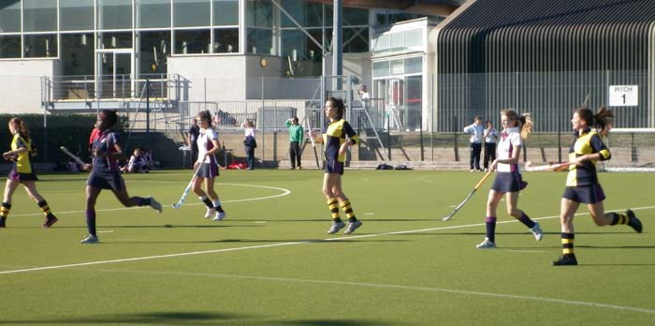
Why might a top British boarding school want to award you a scholarship?
The value of a full scholarship is between £35,000 and £40,000 each year. Why might a school wish to award you such a generous scholarship?
Because you answered yes to all the questions above….and because top British boarding schools want to attract top students….
To apply…
- You must be no younger than 16 years and no older than 17 years and 6 months on 1st September 2020;
- Your average academic attainment must be very high;
- You must intend to study for the full two years of the Sixth Form;
- Your parents or guardians must support your desire to win a scholarship;
- You must apply via the HMC Projects Country Coordinator in your country.
You will need to complete a detailed application form in which you tell us about yourself and your achievements and write about why you want to win a scholarship. You will also organise references from your teachers, take an English Language test and, if invited, you will attend an interview with one or more representatives of HMC Projects. Competition for these scholarships is intense, but if you don’t apply….!
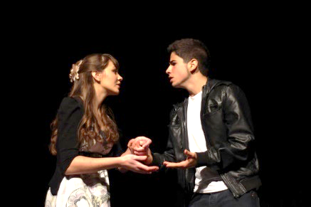
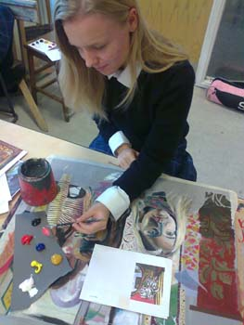
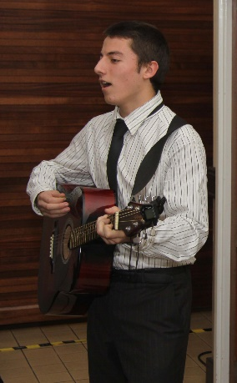
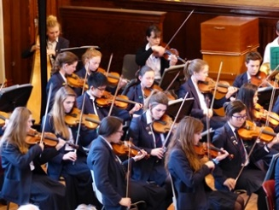
Two Scholarship Programmes:
The Full Scholarship.
HMC Projects Full Scholarships are intended to benefit those whose parents cannot afford to pay full United Kingdom boarding school fees. Schools participating in the Scheme consider this to be part of how they offer public benefit. HMC Projects has therefore decided that the combined parental income of applicants must not exceed £30,000 as assessed during 2018. Your scholarship will cover all your tuition, food and accommodation. You will receive a bursary of £300 to help with other expenses.
The Reduced Fee Scholarship.
If your family’s income exceeds £30,000 you are eligible to apply for a reduced fee scholarship. Reduced fee scholars typically pay between £6,000 and £9,000 each year. This covers tuition, food and accommodation.
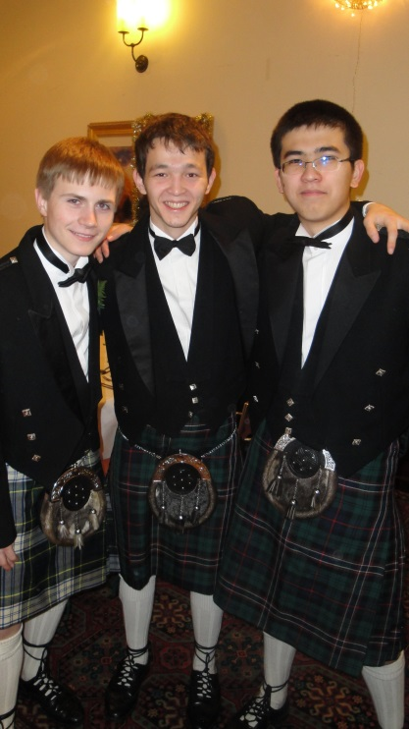

What will you have to pay?
If you win a full scholarship your family will have to pay:
- an administration fee of £1500 if you have a EEA passport;
- an administration fee of £700 if you hold a non-EEA passport plus tier 4 visa and healthcare costs;
- your travel costs to and from the school.
If you win a reduced fee scholarship your family will have to pay:
- reduced school fees – typically between £6,000 and £9,000 each year;
- your travel costs to and from the school.

Applications are made through your HMC Projects Country Coordinator around November time. Information about making an application will be found on the website of your Country Coordinator.
Selection Interviews take place in your country in January or February.
Those awarded scholarships start the new school year in late August or September.
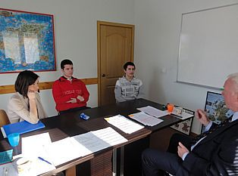
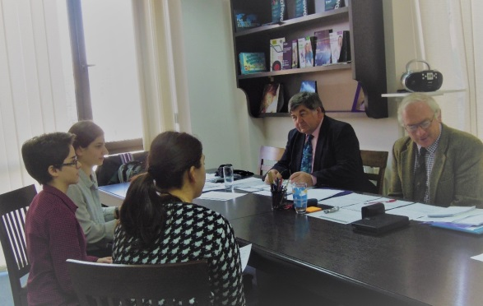
Interviews take place in 14 different countries conducted by an experienced team of interviewers.
And two years later – what then?
Many HMC Projects scholars have gone on to study at British, European or American universities, sometimes in receipt of university scholarships. British qualifications are widely recognised and are used for entry into university in most countries. However, students must check with their own country’s education authorities to find out if they recognize UK qualifications.

Where can I find out more?
- You will find a full introduction to the work of HMC Projects on our website: www.hmcprojects.org.uk.
- The sections Student FAQs, Comments from Scholars, Thoughts about my Year will provide answers to most of your questions…
- Ask your Country Coordinator.
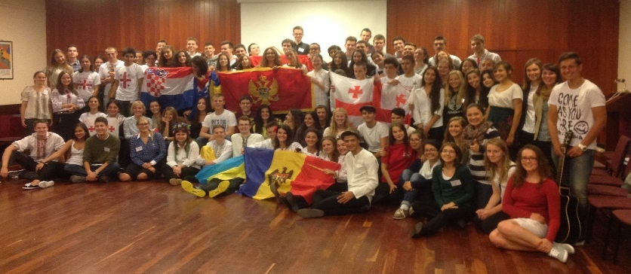
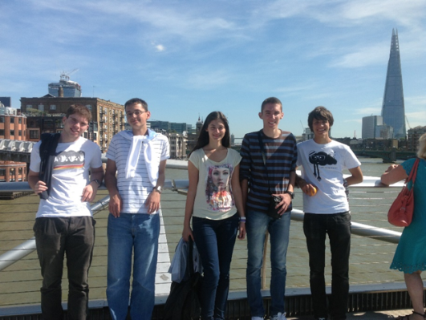
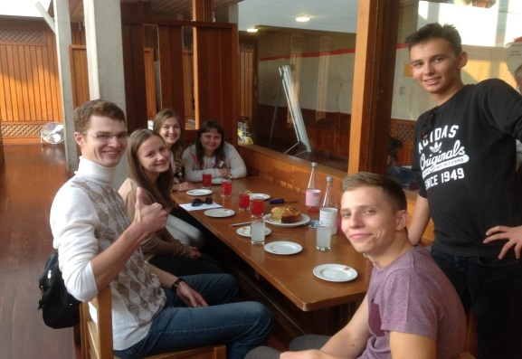
What scholars say about their experience:
“I have had an amazing experience here in the school, made loads and loads of friends and I can say that this scholarship has changed my life.”
“Being in England has been the most amazing experience, it has been extraordinarily eye opening for me to be a part of this type of education. I am incredibly happy to find every single one of my subjects really interesting and personally fulfilling. It has really helped me to discover my academic strengths and interests.”
“Even though I didn't realize it at the time, the HMC scholarship has kick-started my life and I have been on top of my game ever since.”
“The joy of rolling full and empty tin cans of baked beans to calculate inertia, to boil the bark of a willow tree to extract salicin…real education! I met new people, learned new things, engaged in new activities, made new mistakes.”
“I did everything I could at my school: I sang, I acted, I danced, I worked for charity, I joined an Italian club, I wrote for the school newspaper, I attended Peer Support training, I did Community Service. I enjoyed every aspect to its fullest, because at home I do not have all these opportunities and I have to live in the moment.”
“The HMC Projects scholarship gave me a chance to expand my national citizenship into a global citizenship – my entire life since leaving my UK school has been influenced by this change for which I am extremely grateful.”

